Irfan Ahmed

ICP 5

Due Date: 9/28/2019

* 1. What you learned in the ICP.

I found this topic to be the most enjoyable so far. One of the main takes away from this ICP was how to logically setup my layers. After my data was train and tested on the dataset, it was normalized. Now the question arises, what should I perform next? I learned that applying one-hot encode would be the best option. One-hot encoding can be applied to the integer representation and doing so a new binary variable is added for each unique integer value. Also, few other concepts like convolution layer, pooling layer, and dropout method were experimented with to better understand the material. Different types of activation and optimizer were used to better understand what purpose they serve, and why one is used over the other. The importance of finding the right batch size and epochs can also affect the accuracy of the results.

* 1. ICP description what was the task you were performing

1. One of the first task was to upload the dataset and perform train/test on it.
2. Then the X and Y, train/test were normalized between 0 and 1 by dividing by 255.
3. One-hot encode was performed on the y_train, Y_test.
4. Next, the model was layed out using the Keras model, which acts as the blueprint.
5. The first layer of the model was the convolutional layer. This layer takes in the input and runs convolutional filters on them
6. Next, the drop layer was added to prevent overfitting, and batch normalization was also applied. Activation(‘relu’) was used.
7. Polling layer was then added to make the classifier more robust.
8. Additional convolution layers were added to increase the number of filters.
9. After the convolution was finished the data was flattened and added dropout layer.
10. Denser layer was added specified the number of dense layers for each step.
11. In the final layer the number of classed was passed comparable to the number of neurons.
12. The model was finally compiled, and model fit was performed on the X_train, and y_train.
13. Then five new images were valeted to see the accuracy of the model.
14. In the final step 4 hyper-parameters were changed to see how it would affect the overall model accuracy(EX: Epochs, Batch Size, Dropout, and optimizers)
    1. Challenges that you faced.

One of the difficult parts was understanding the different layers and how many to add. Adding can hurt the overall model and finding that sweet spot can be difficult. Mostly understanding the code and what is doing can be the most difficult part at times.

* 1. Screen shots that shows the successful execution of each required step of your code

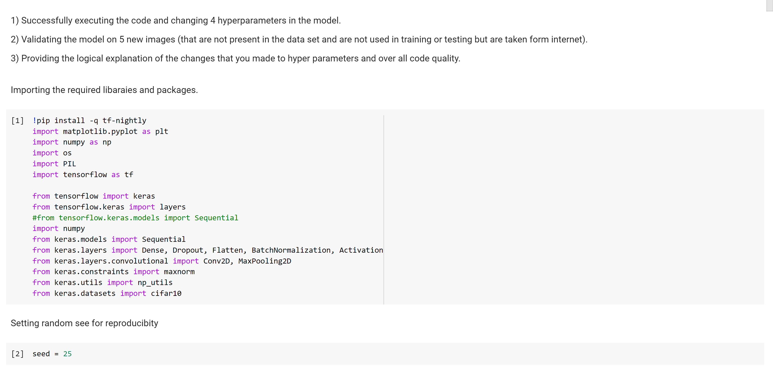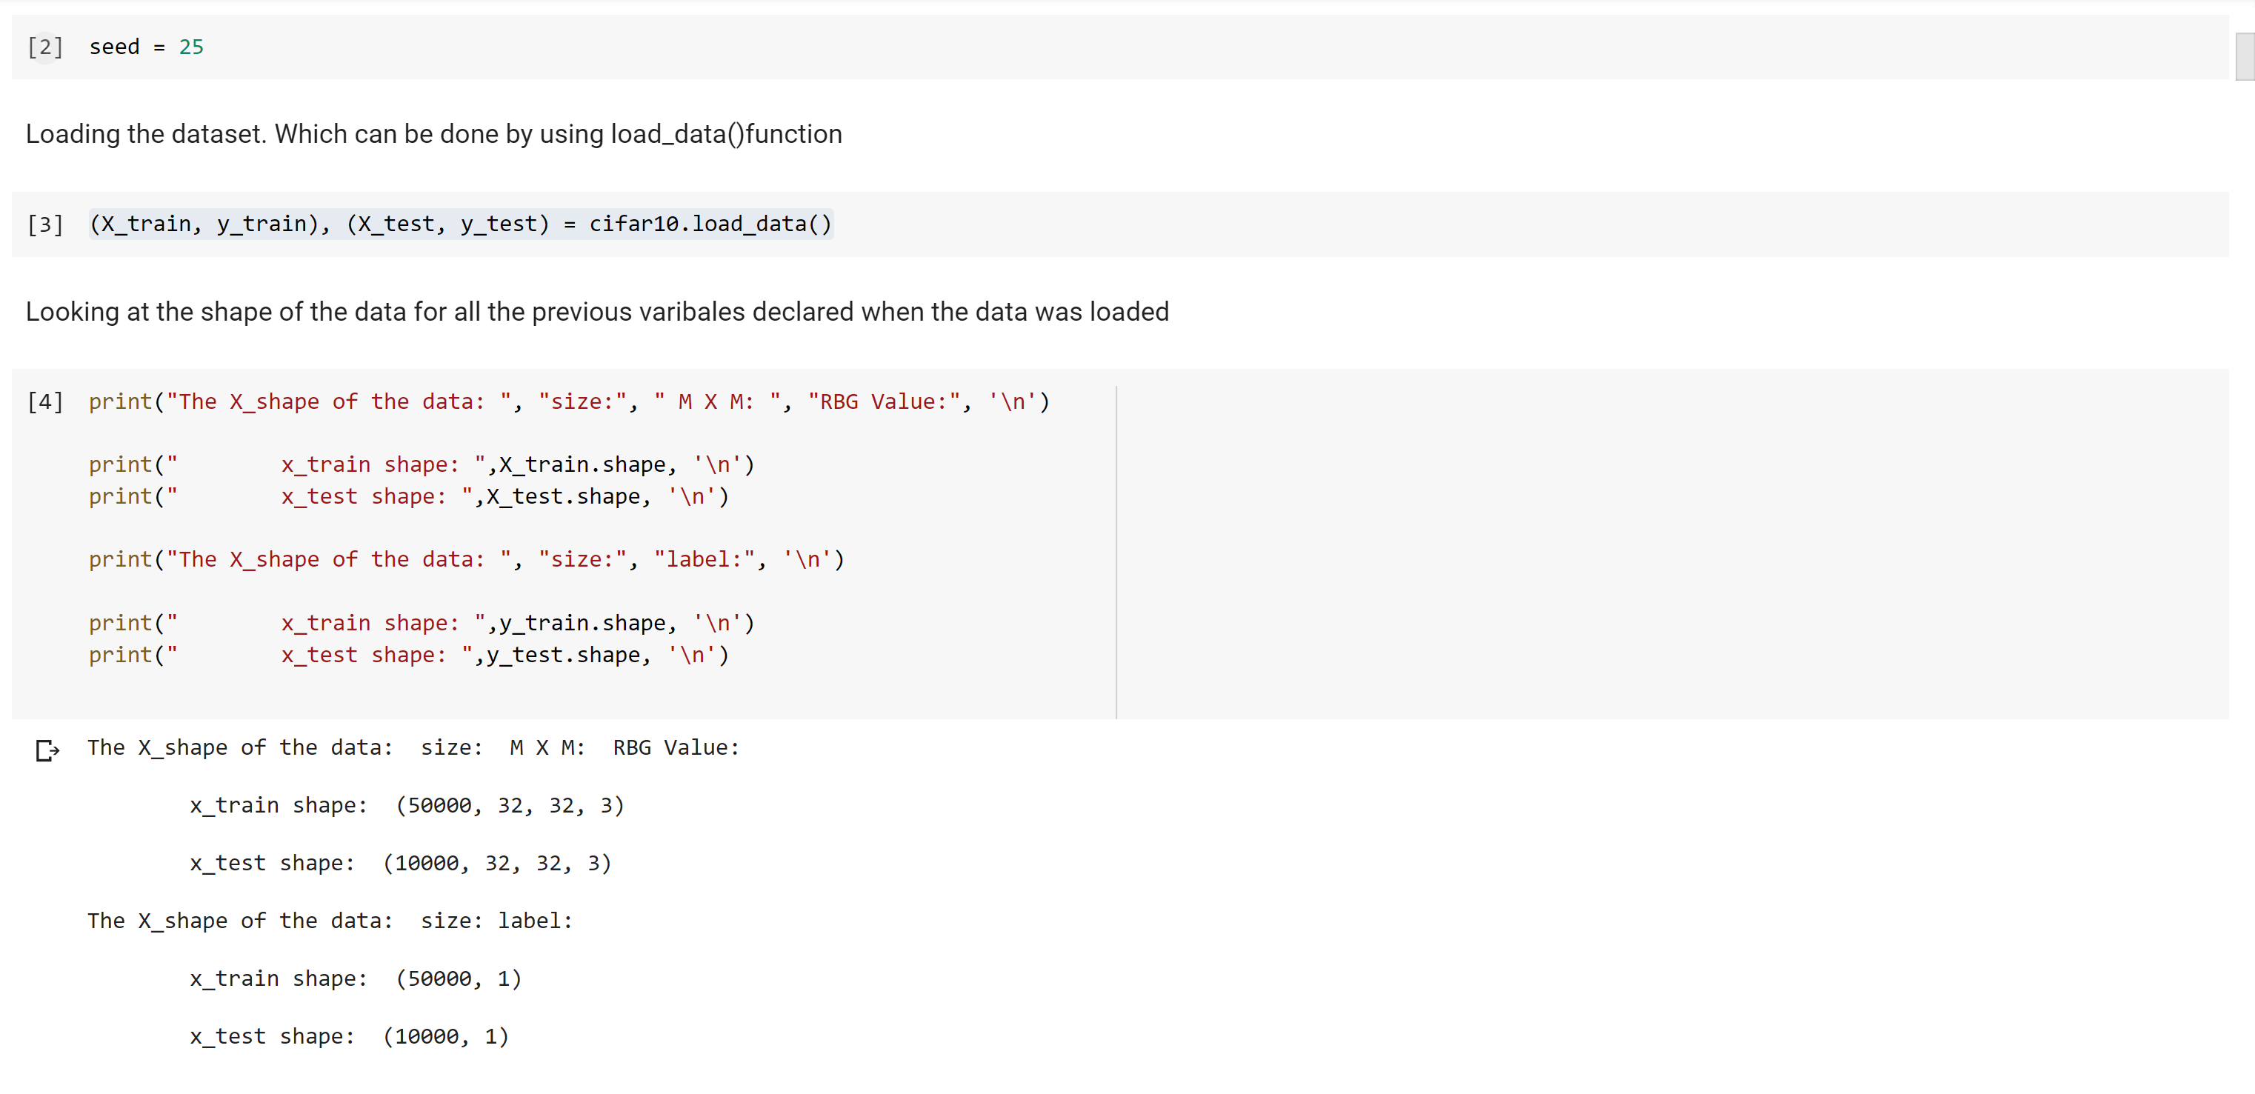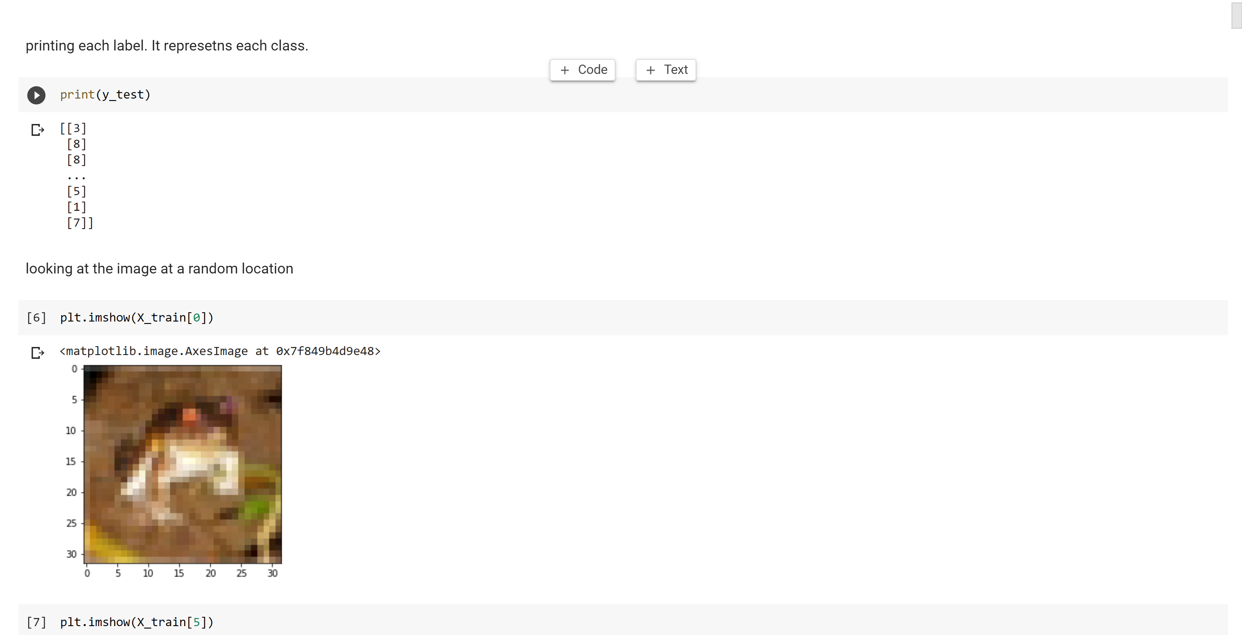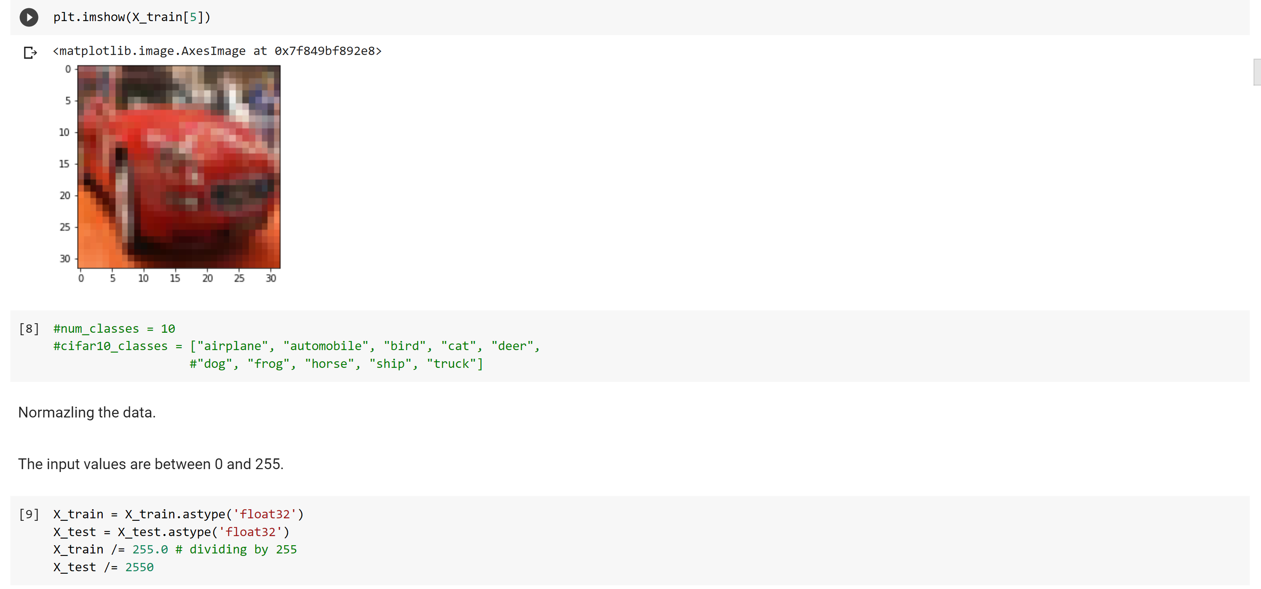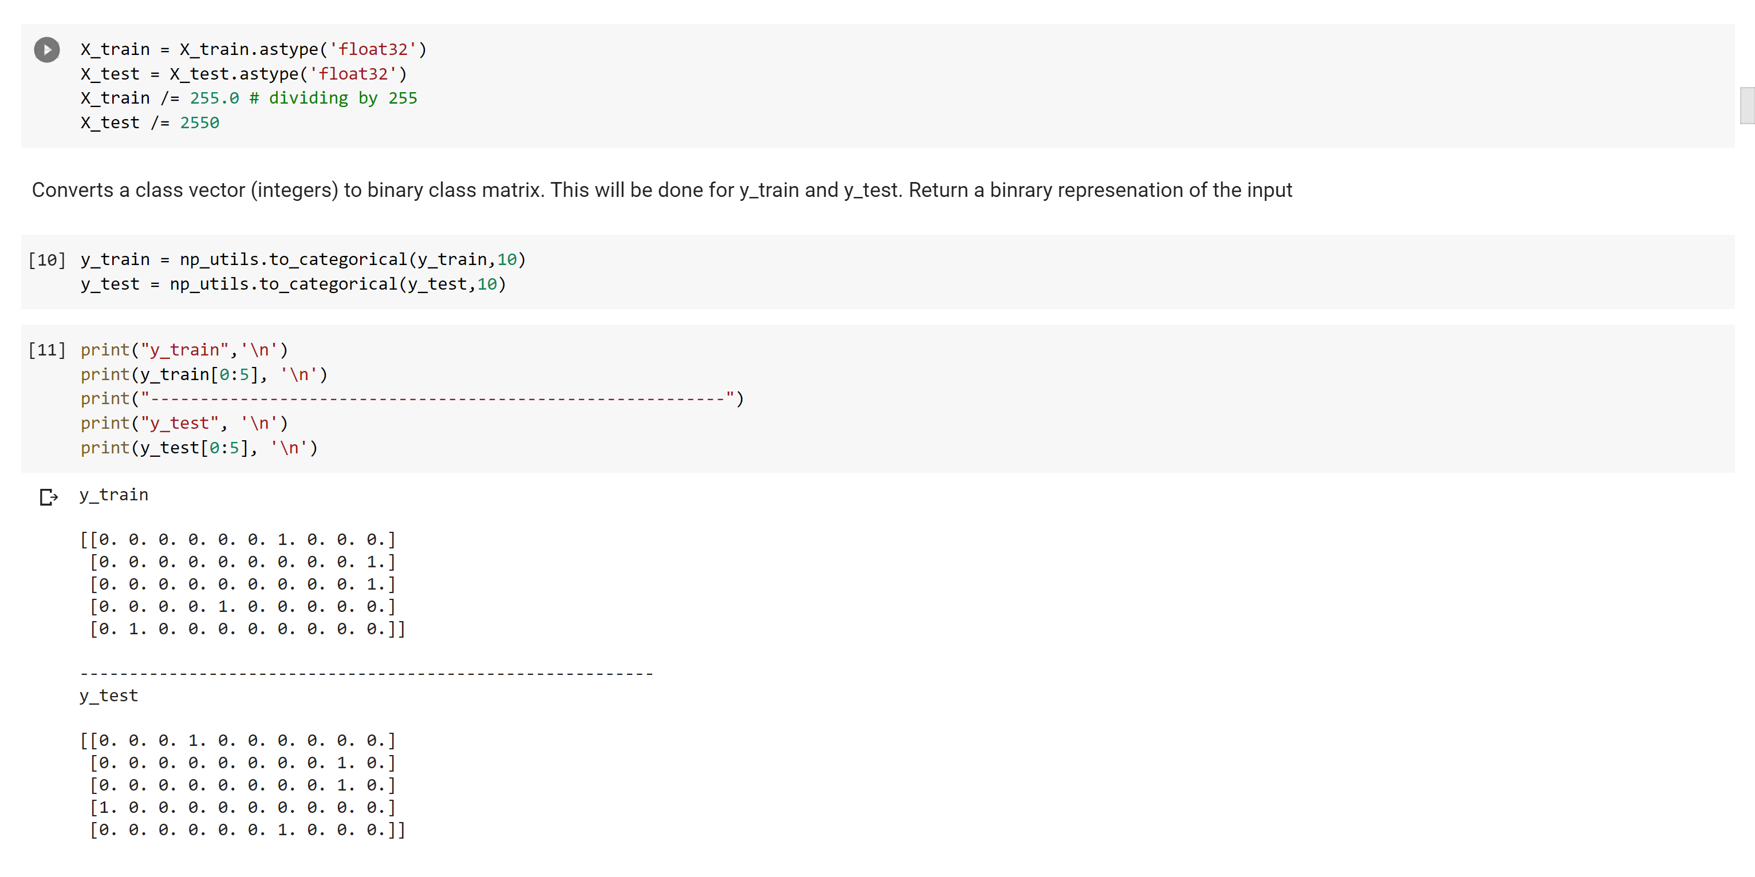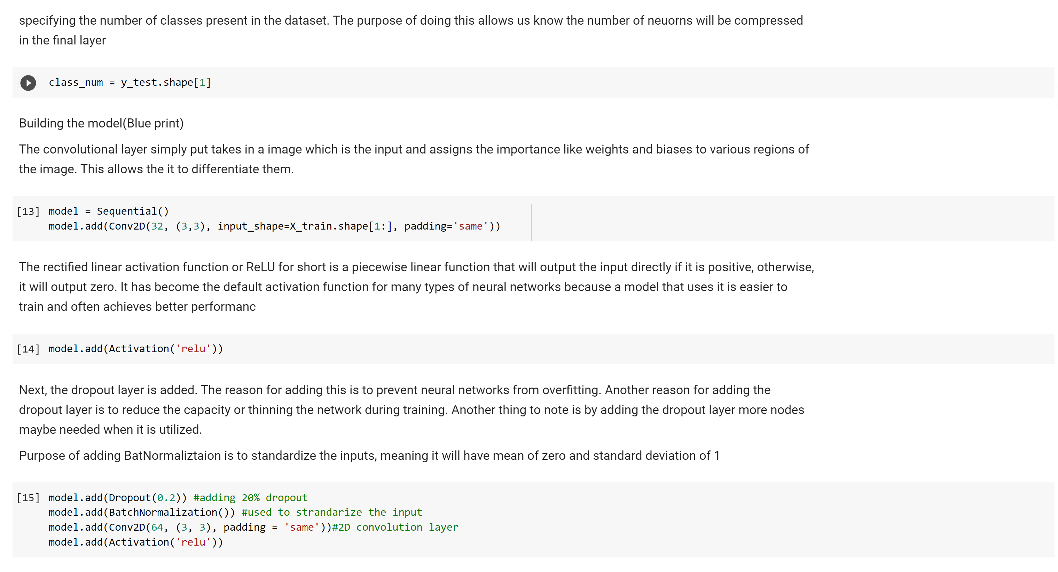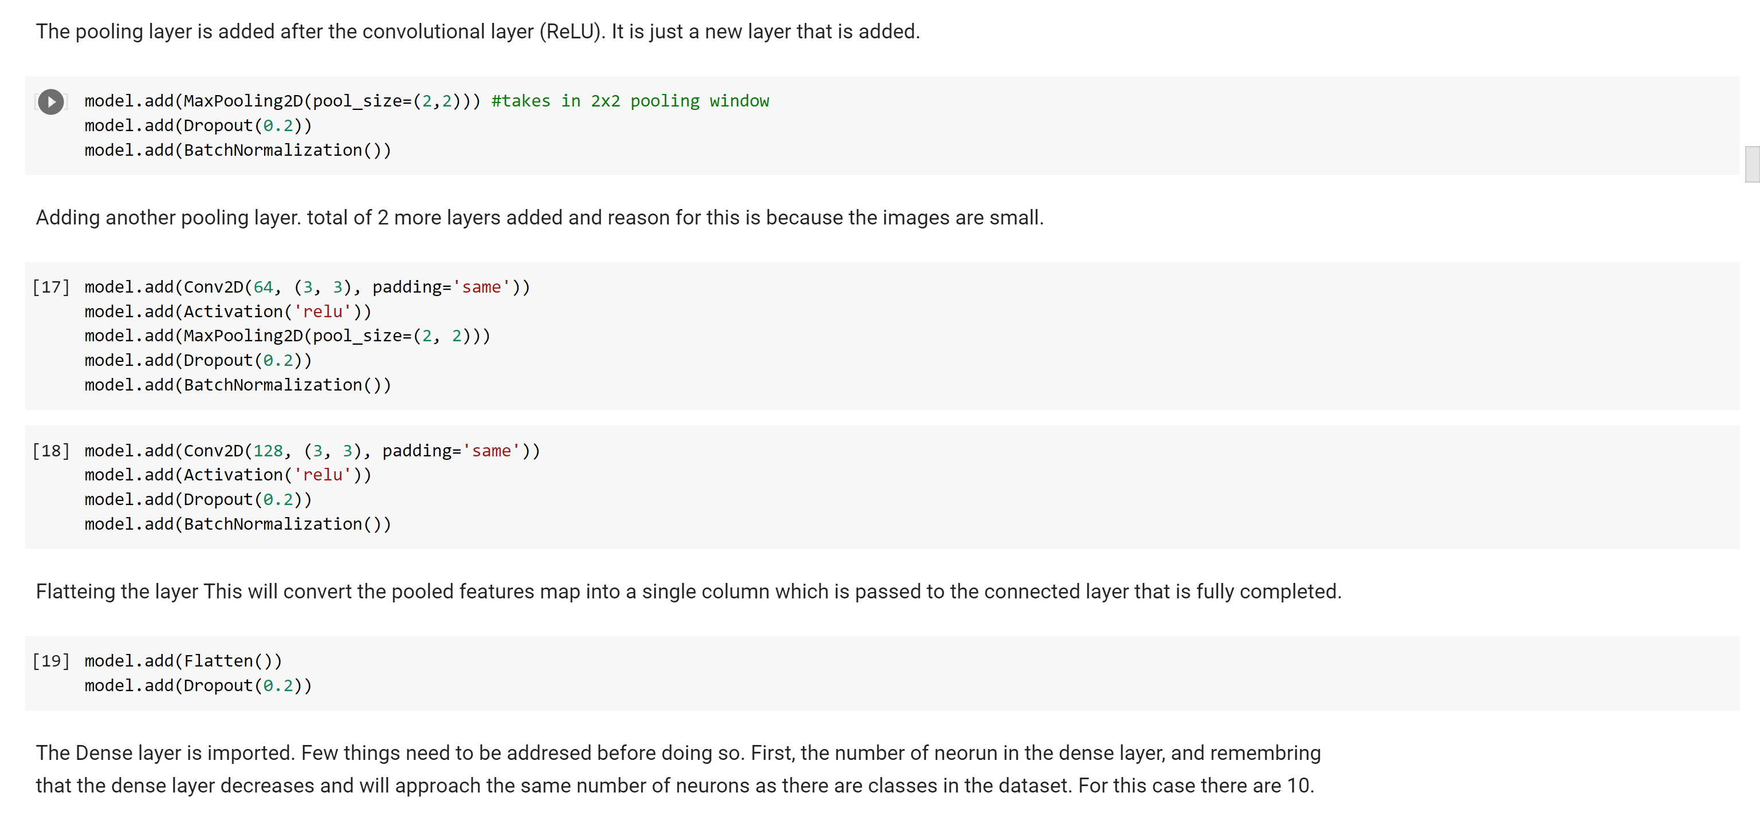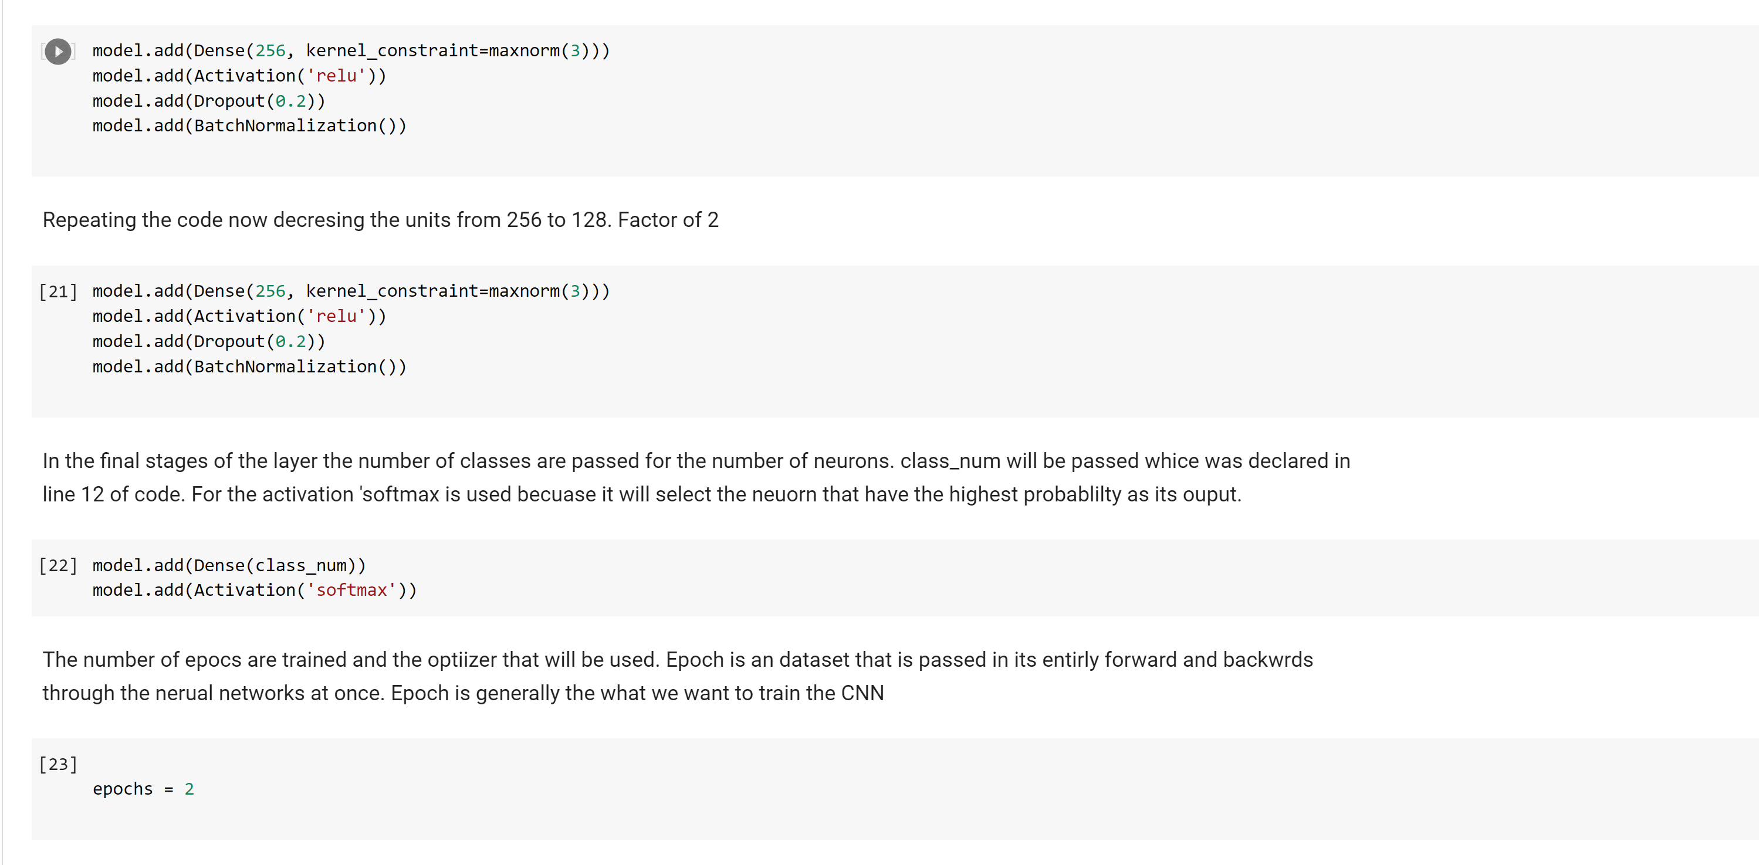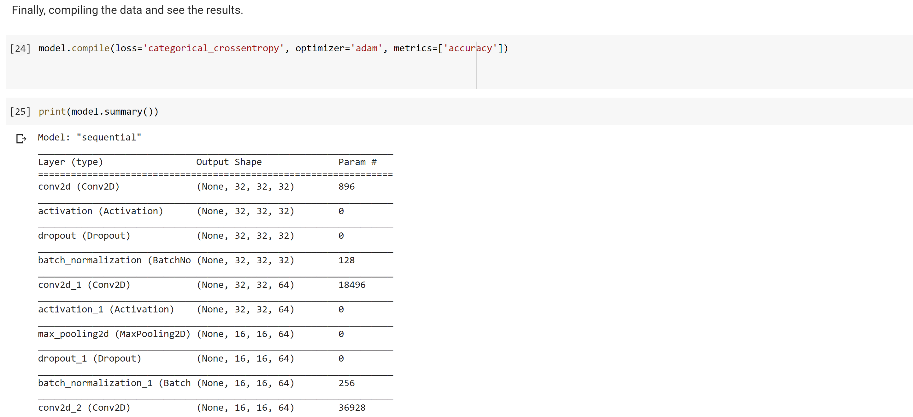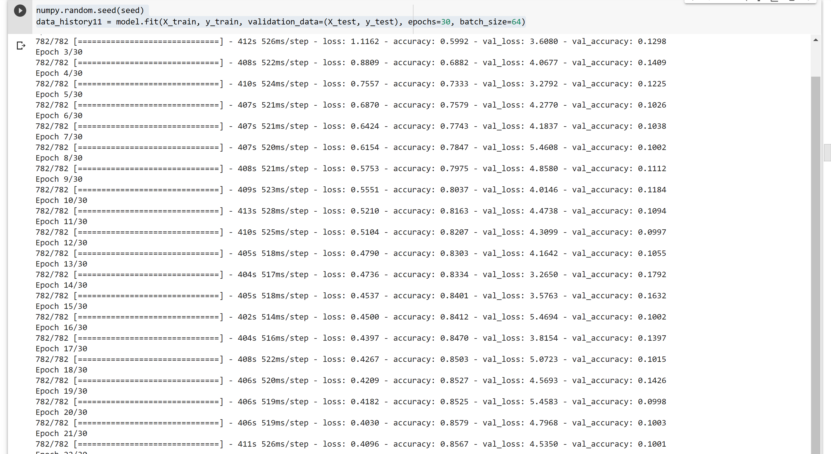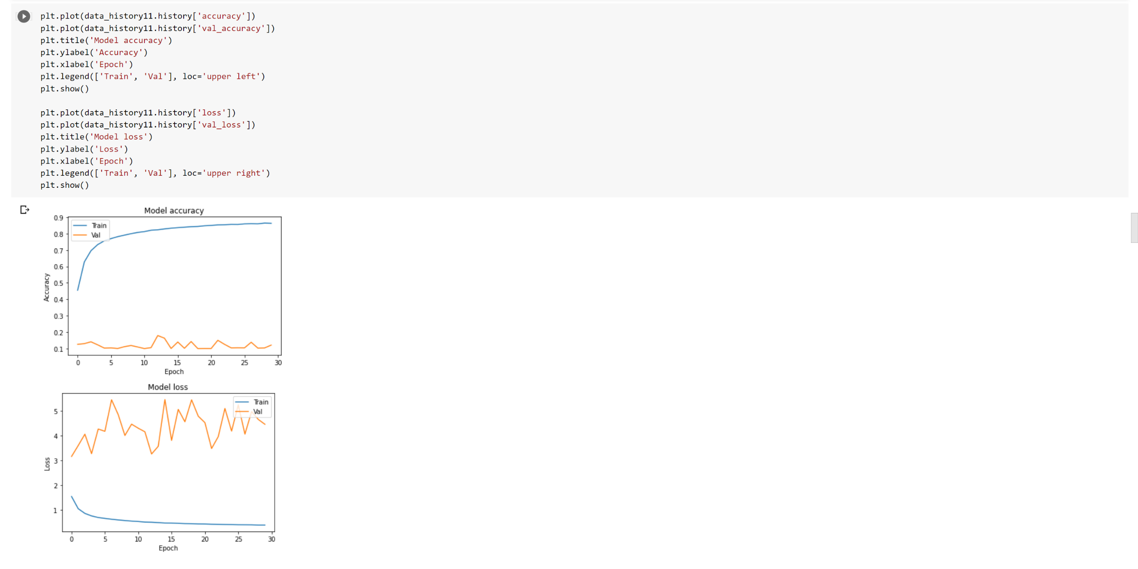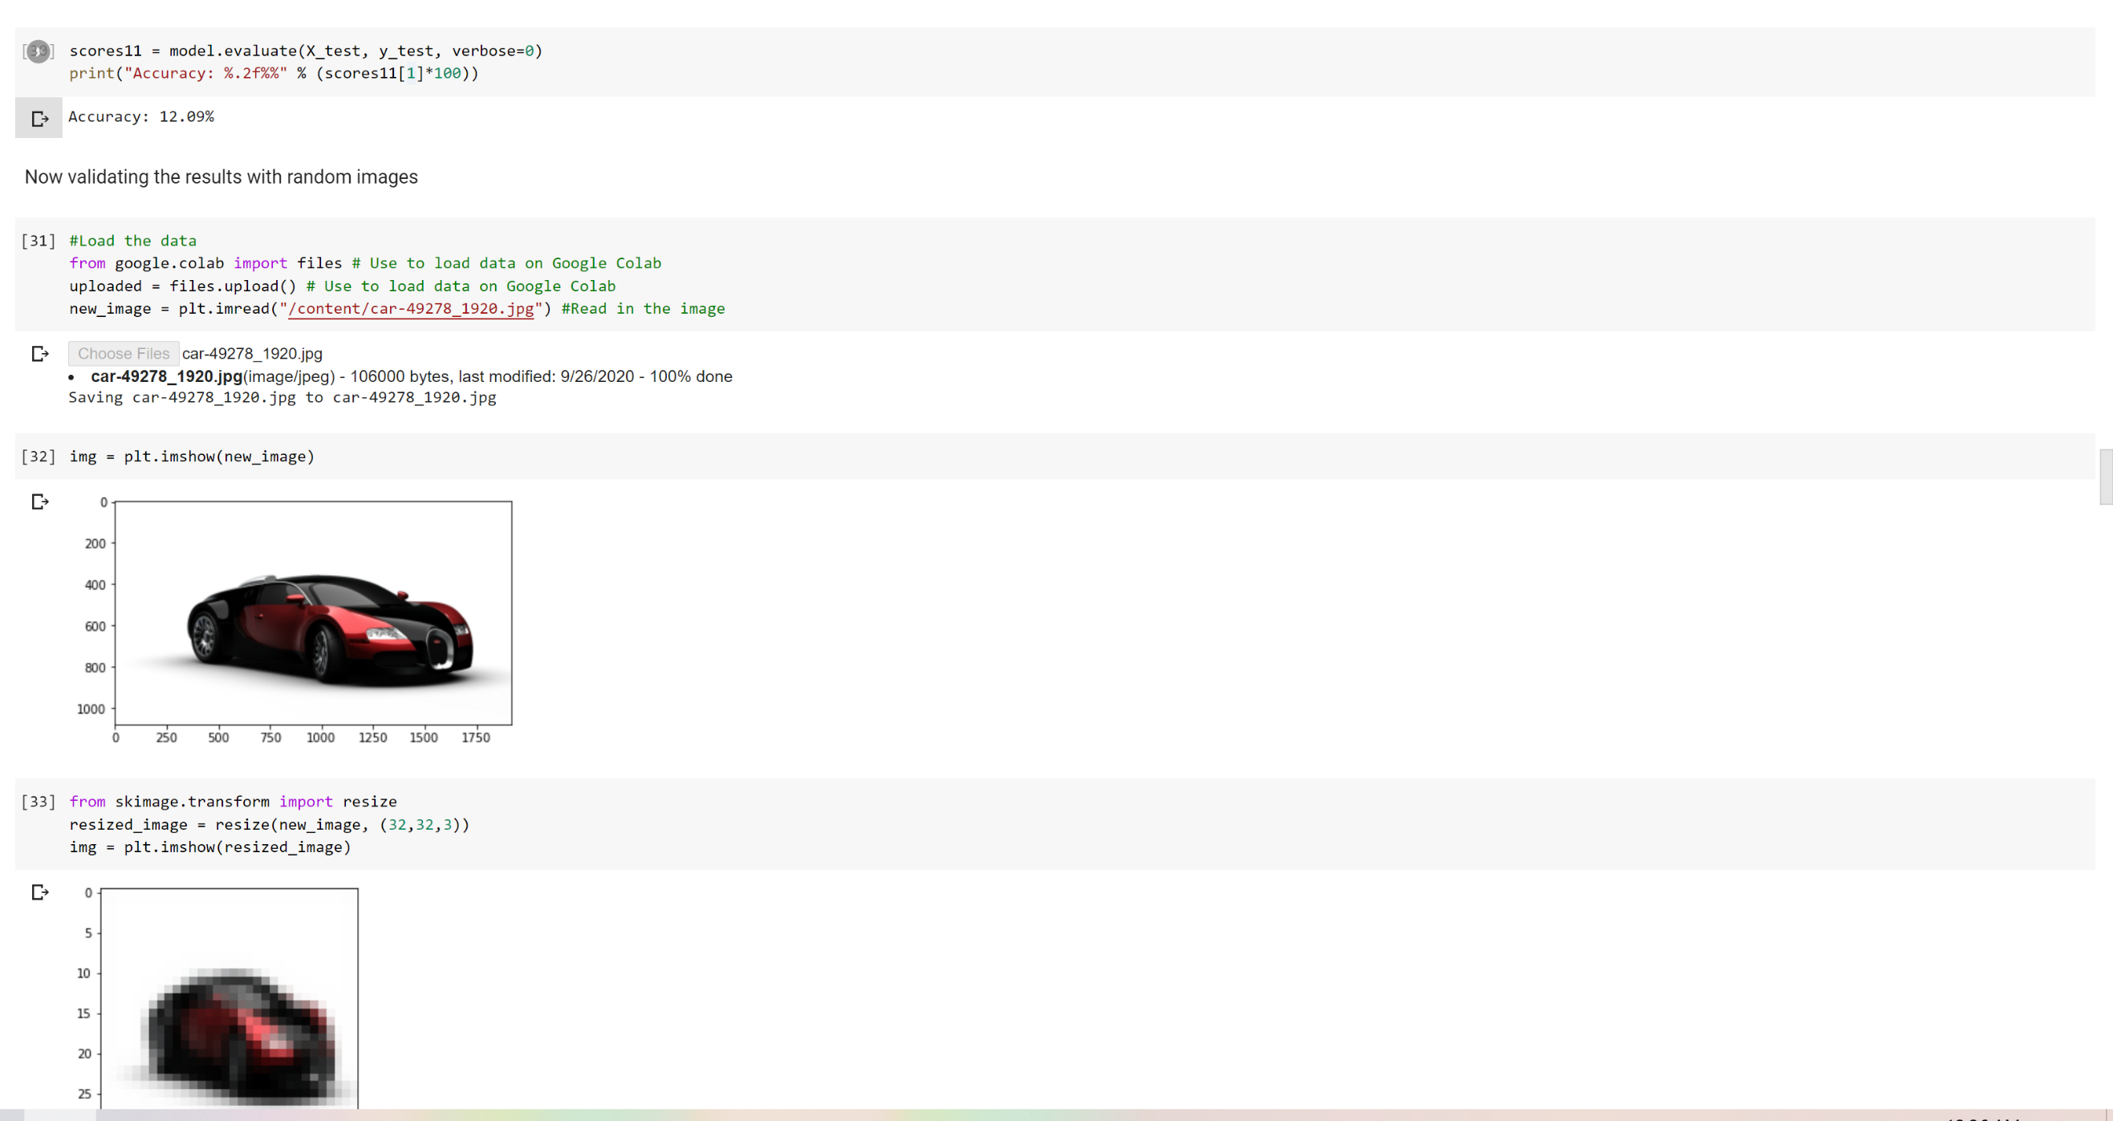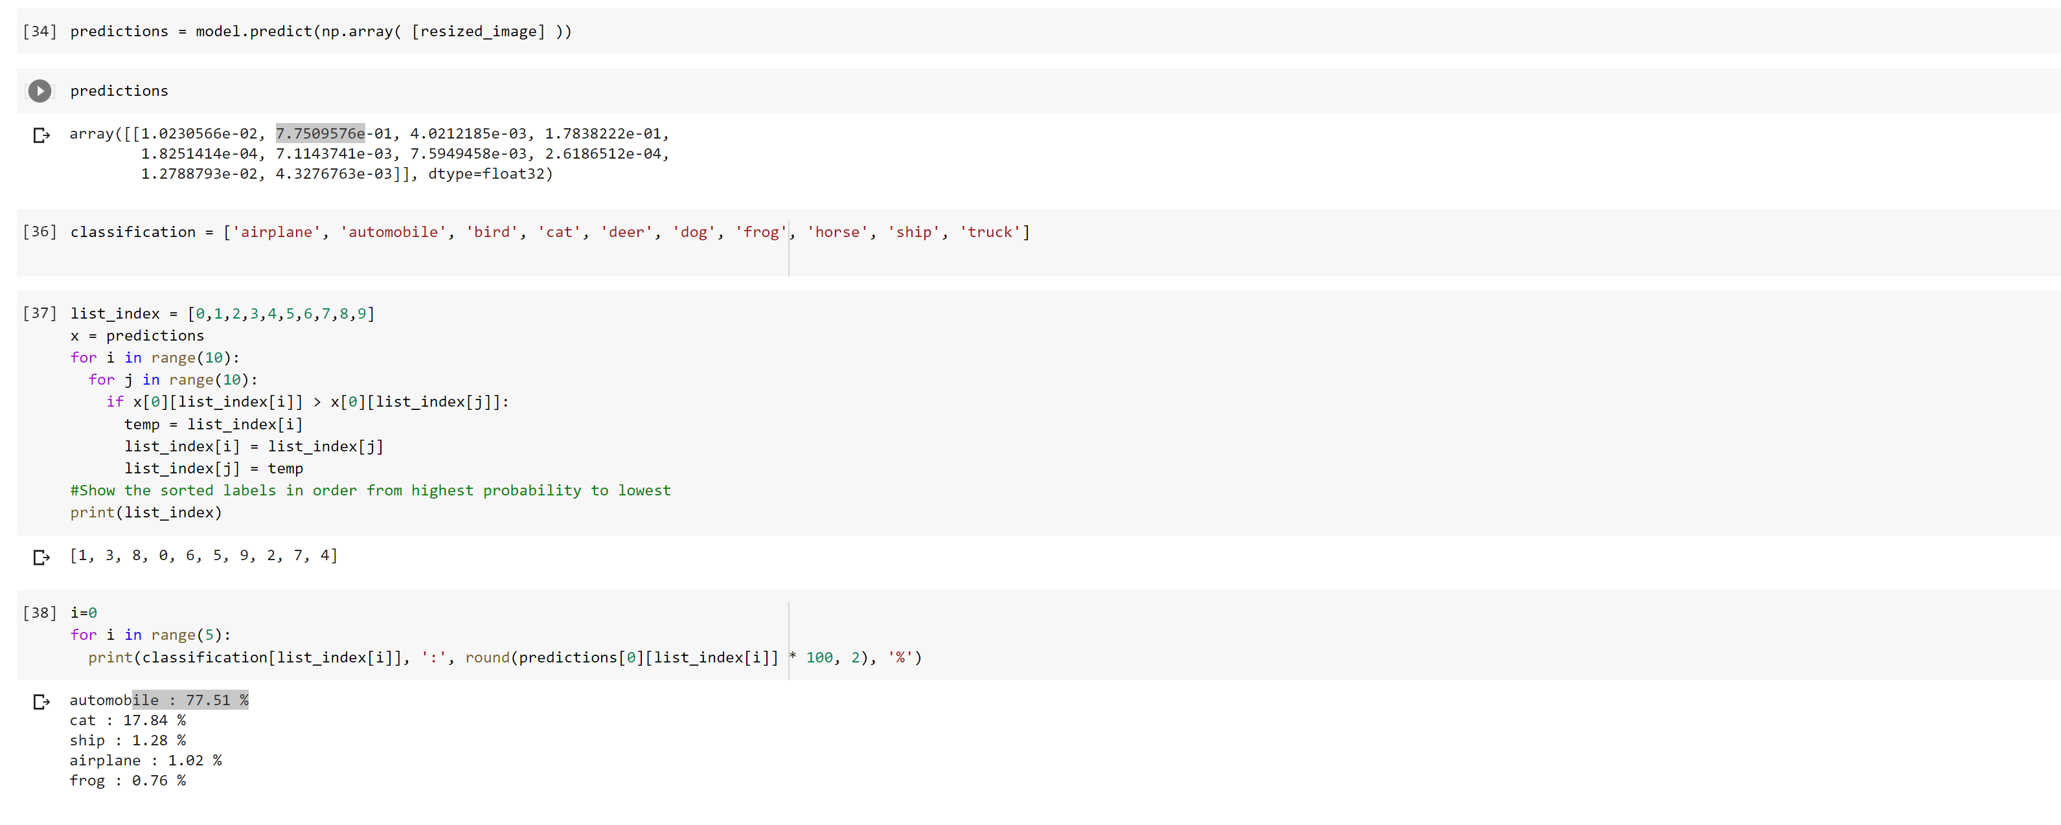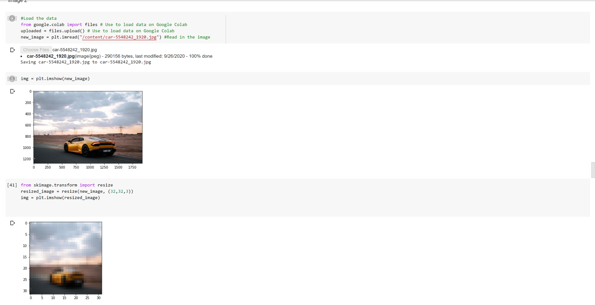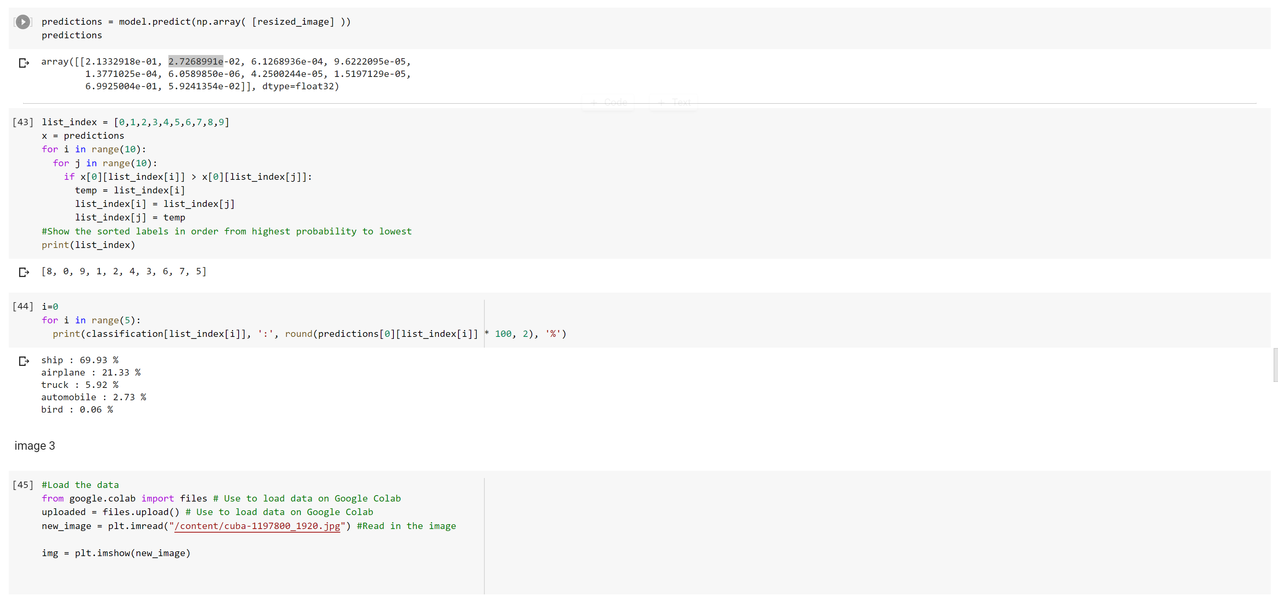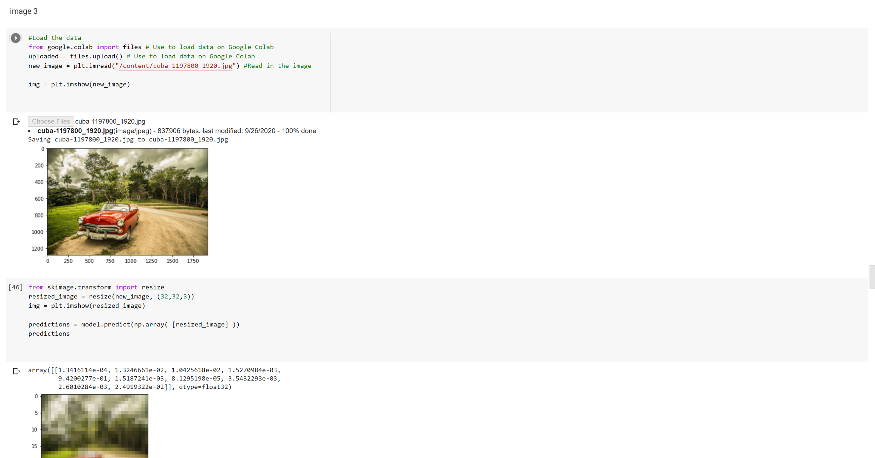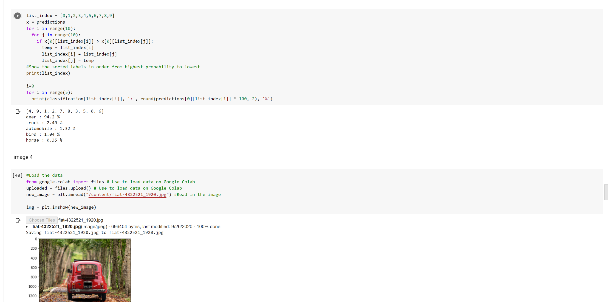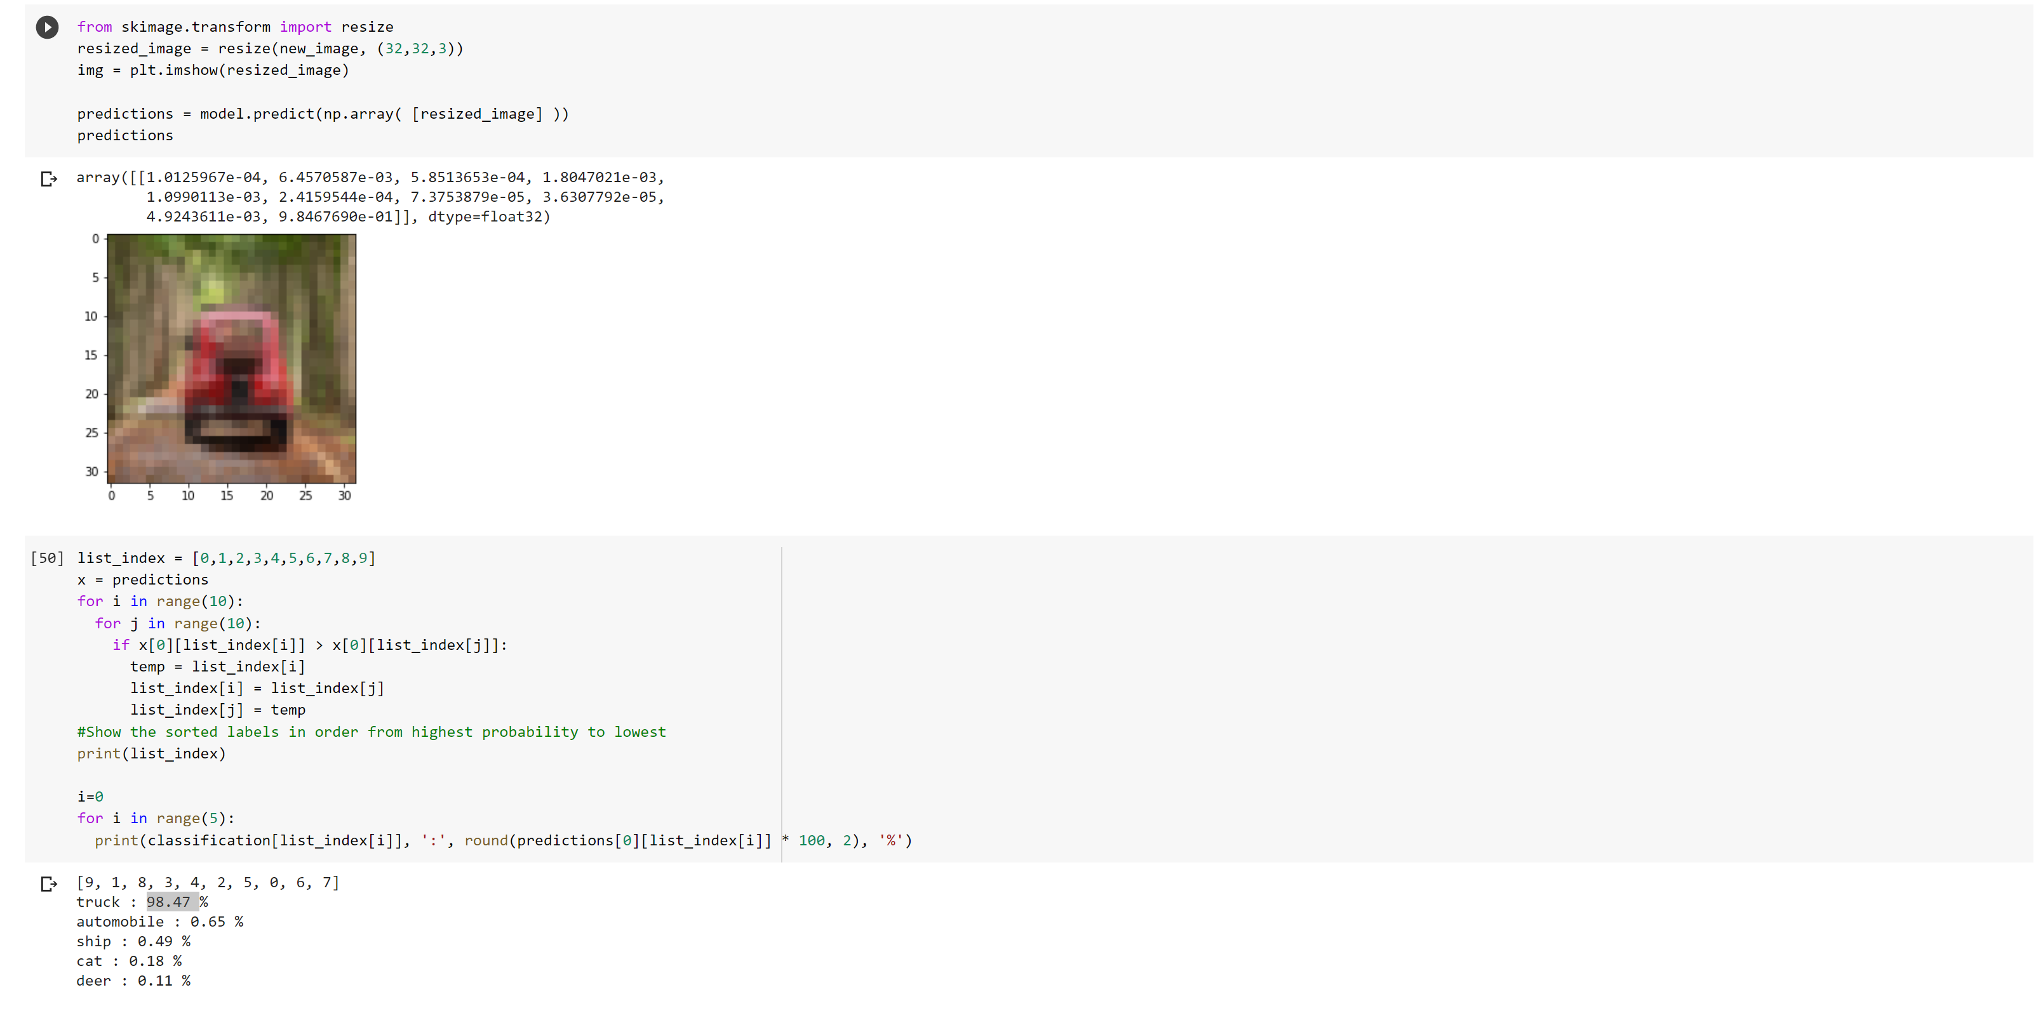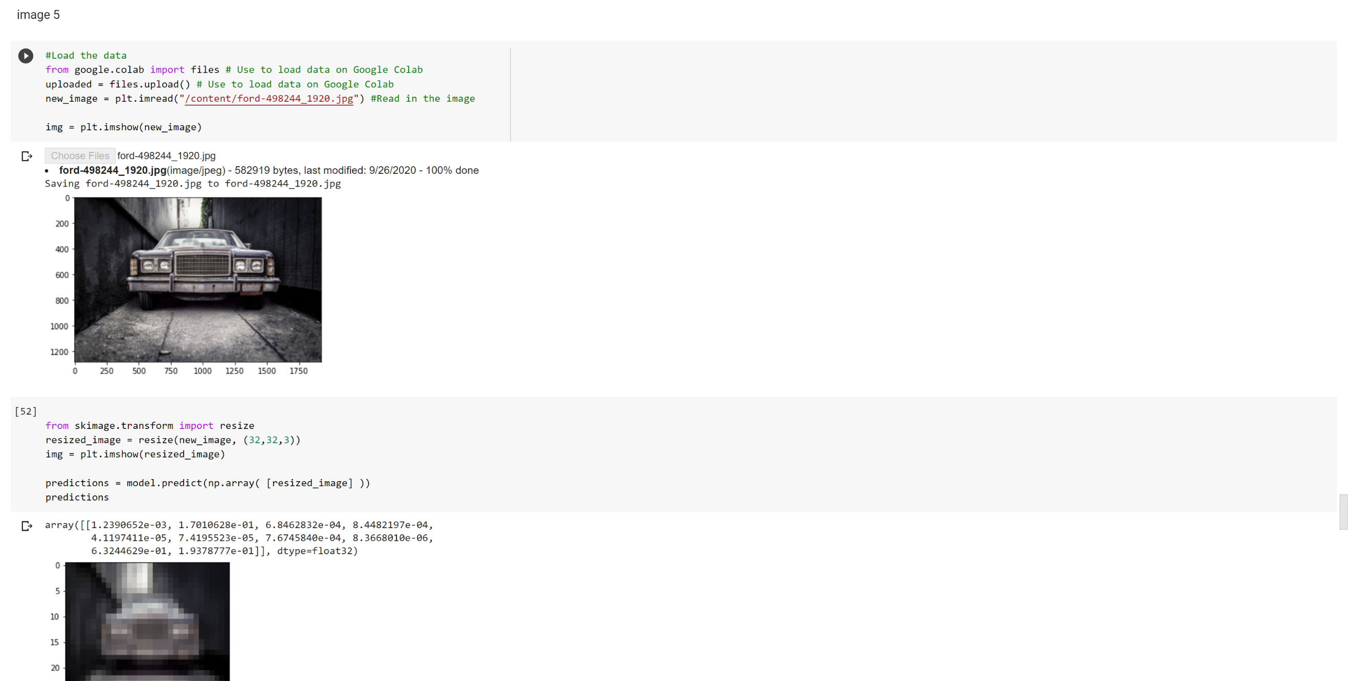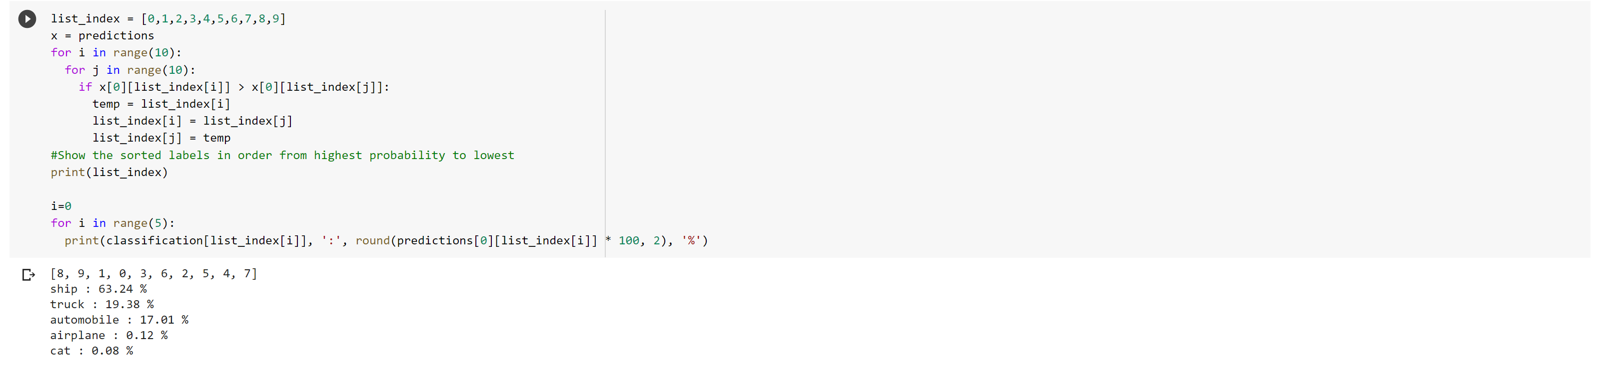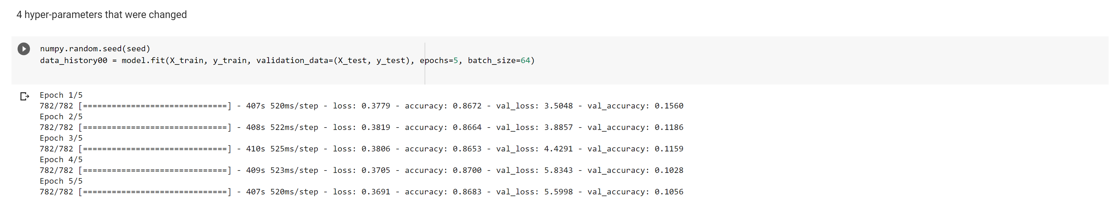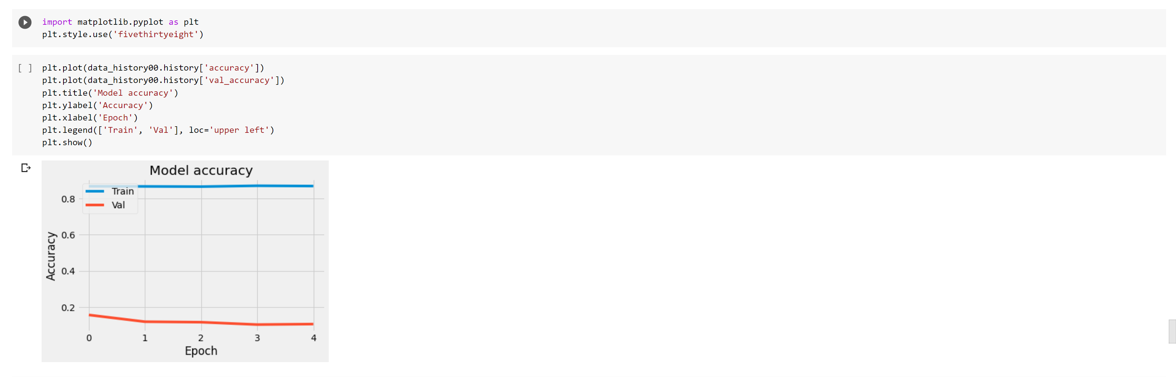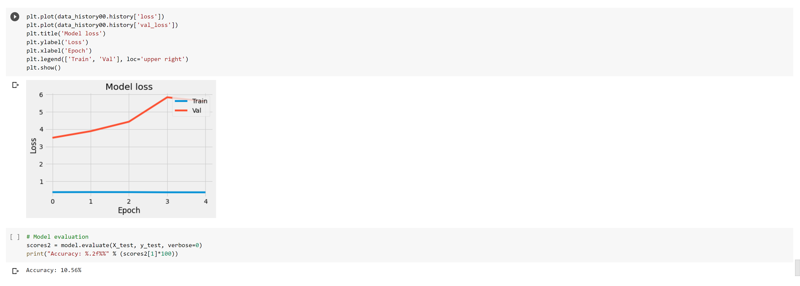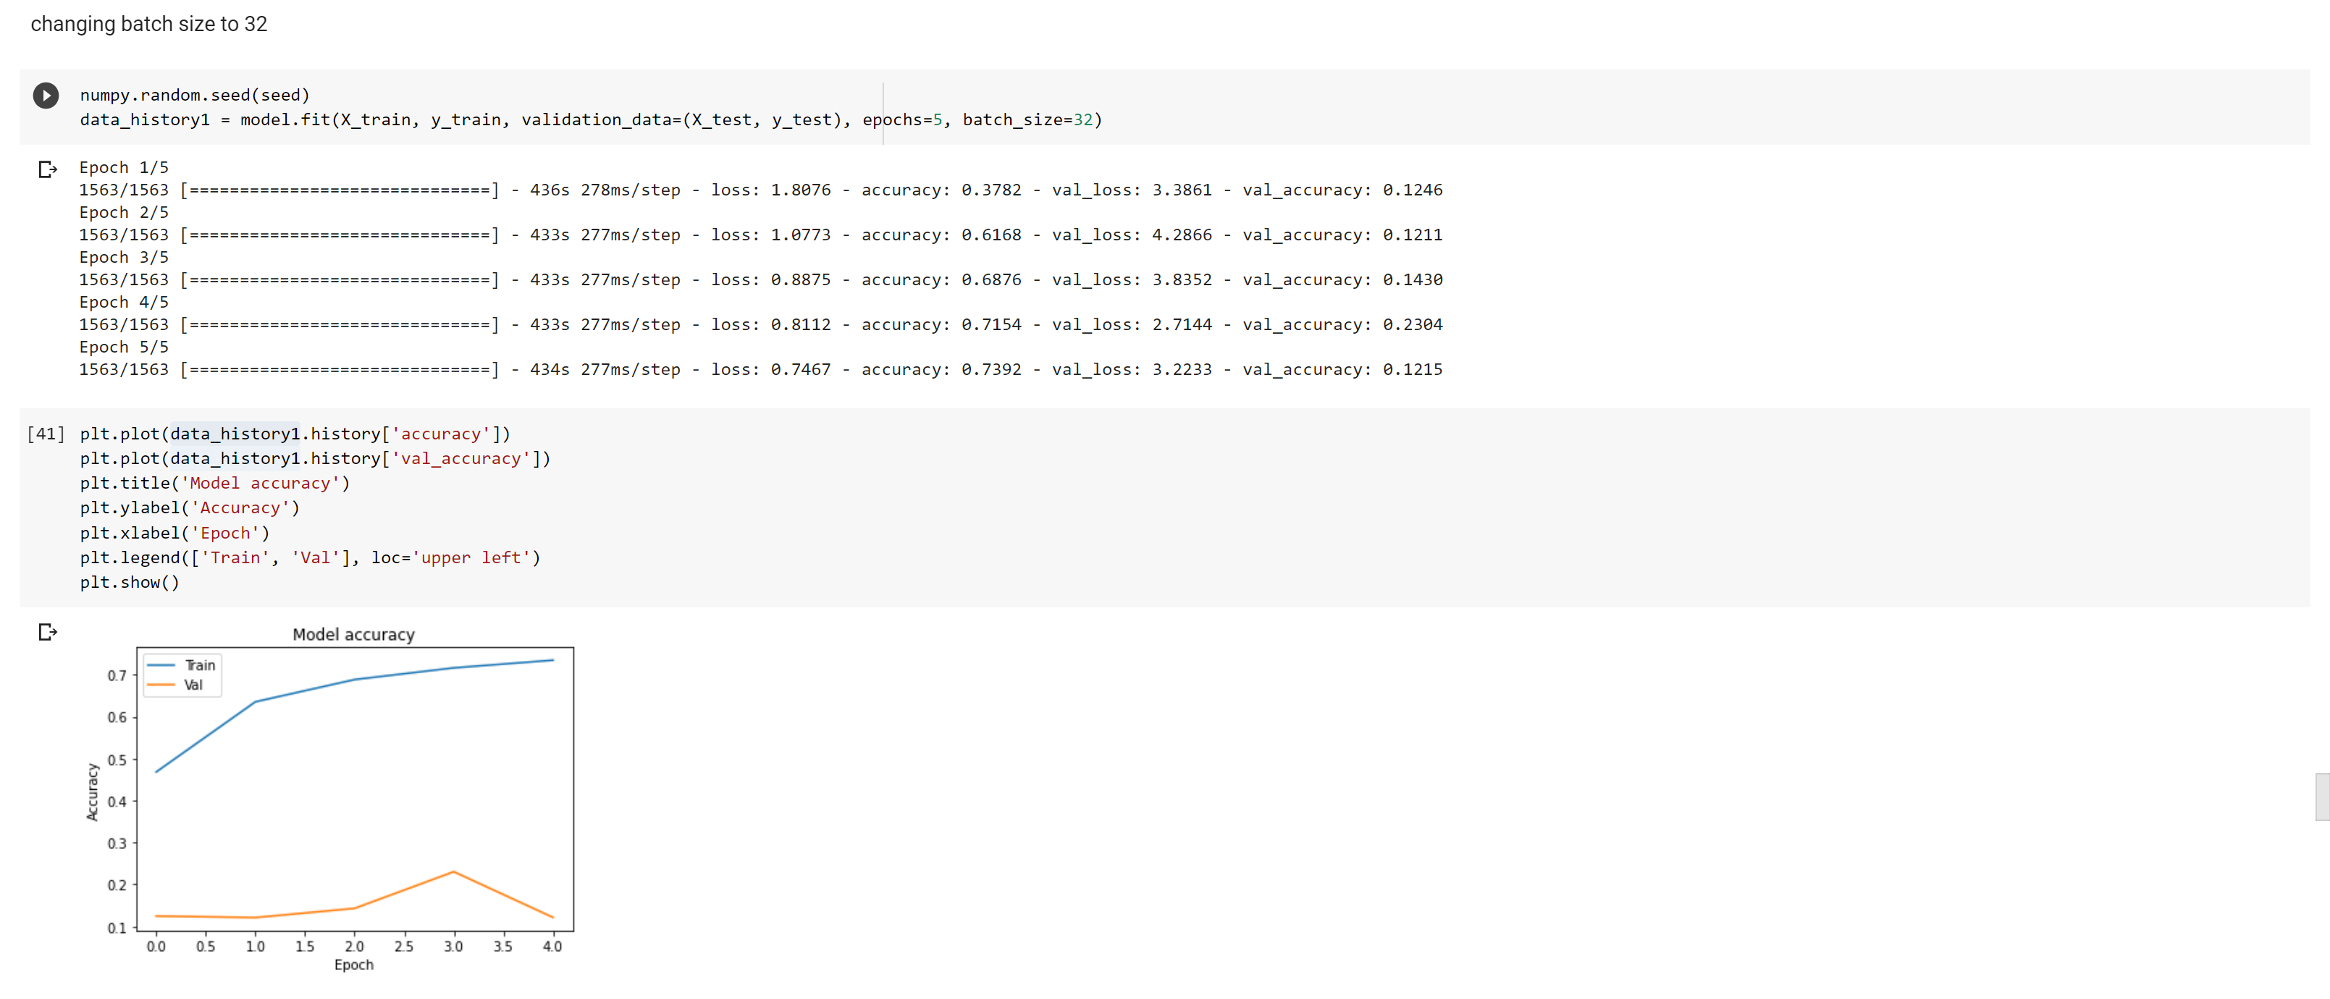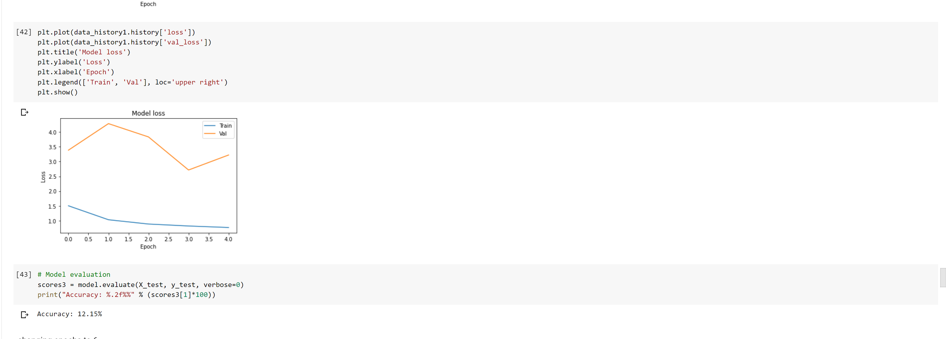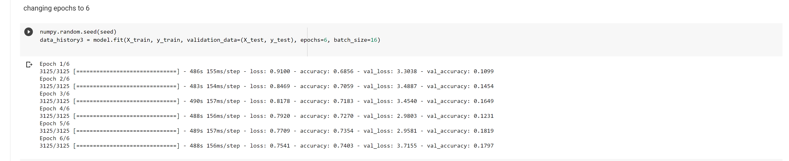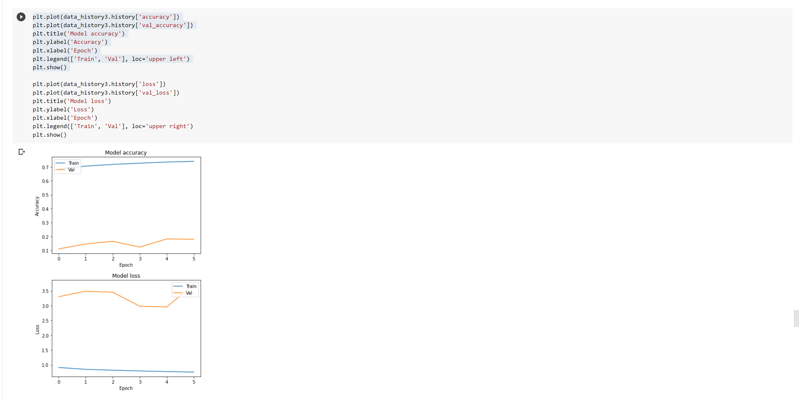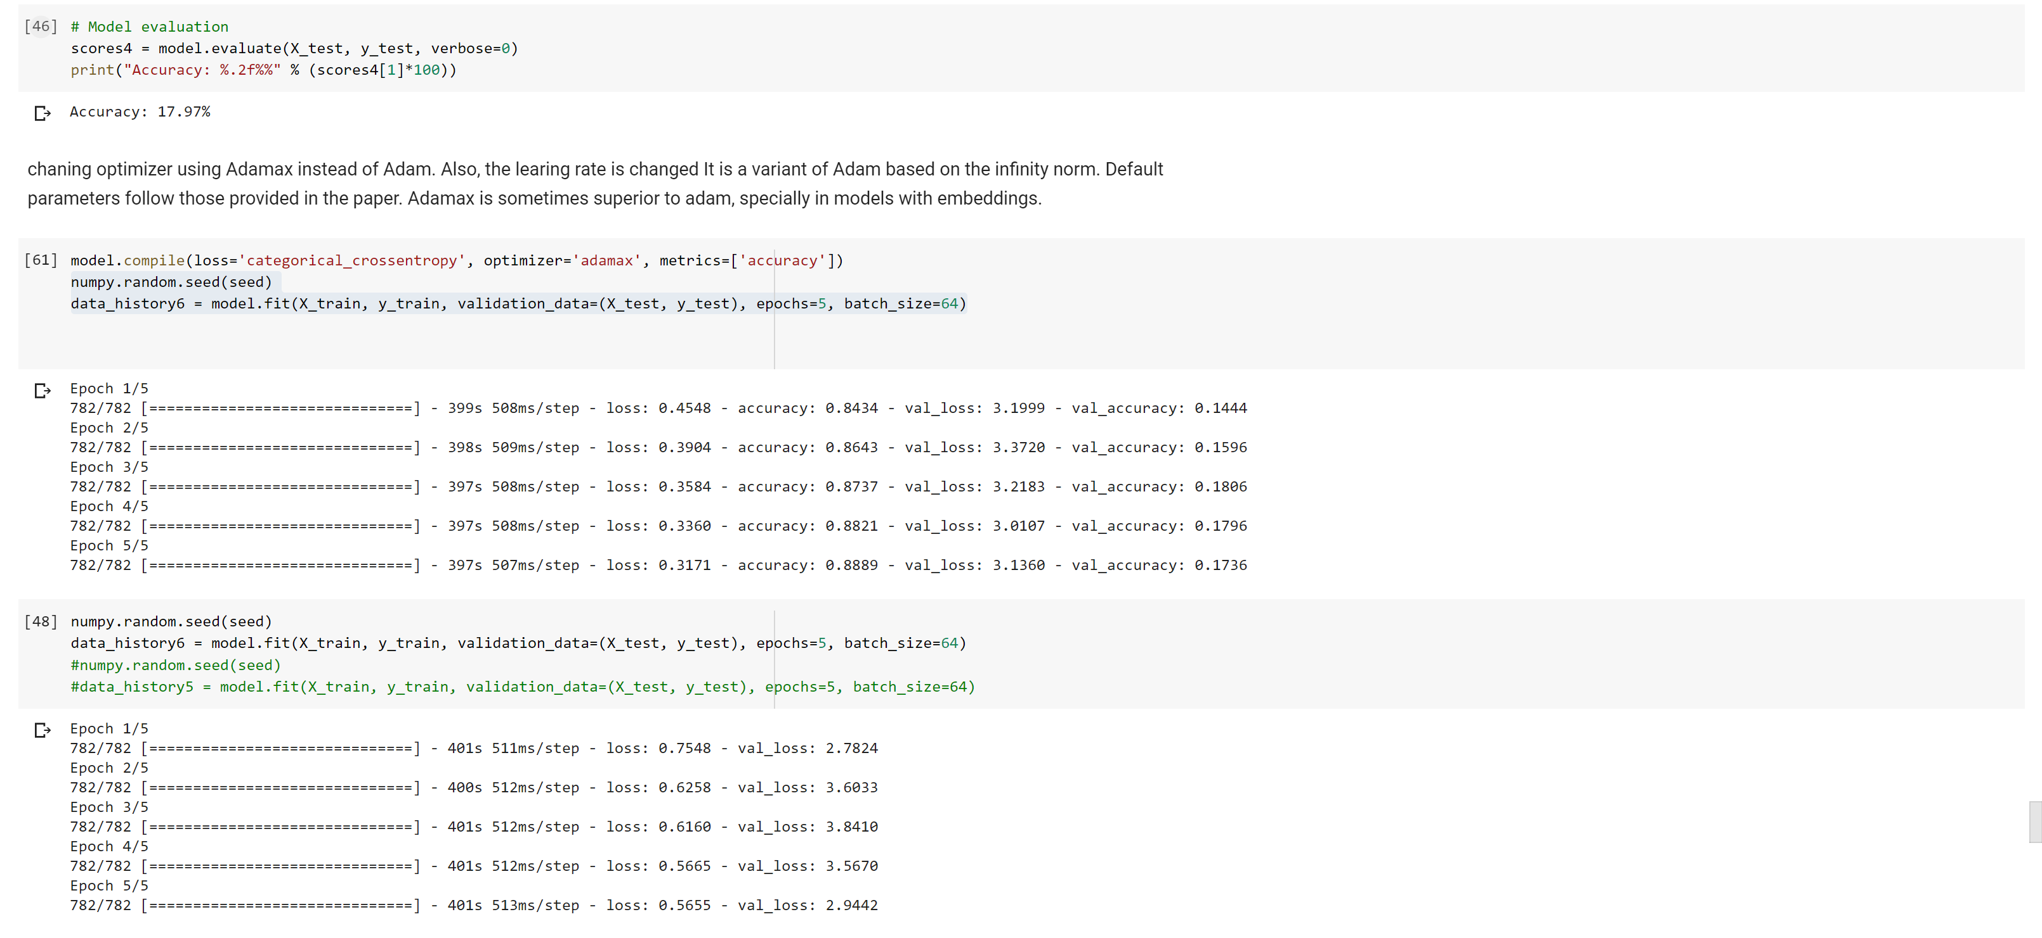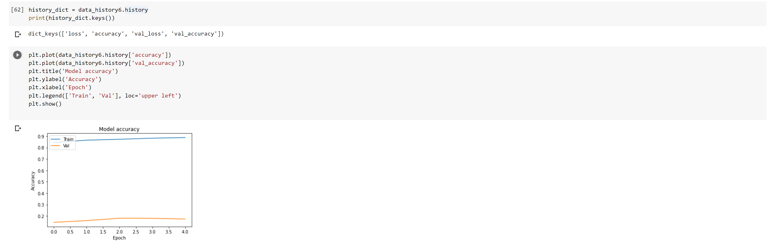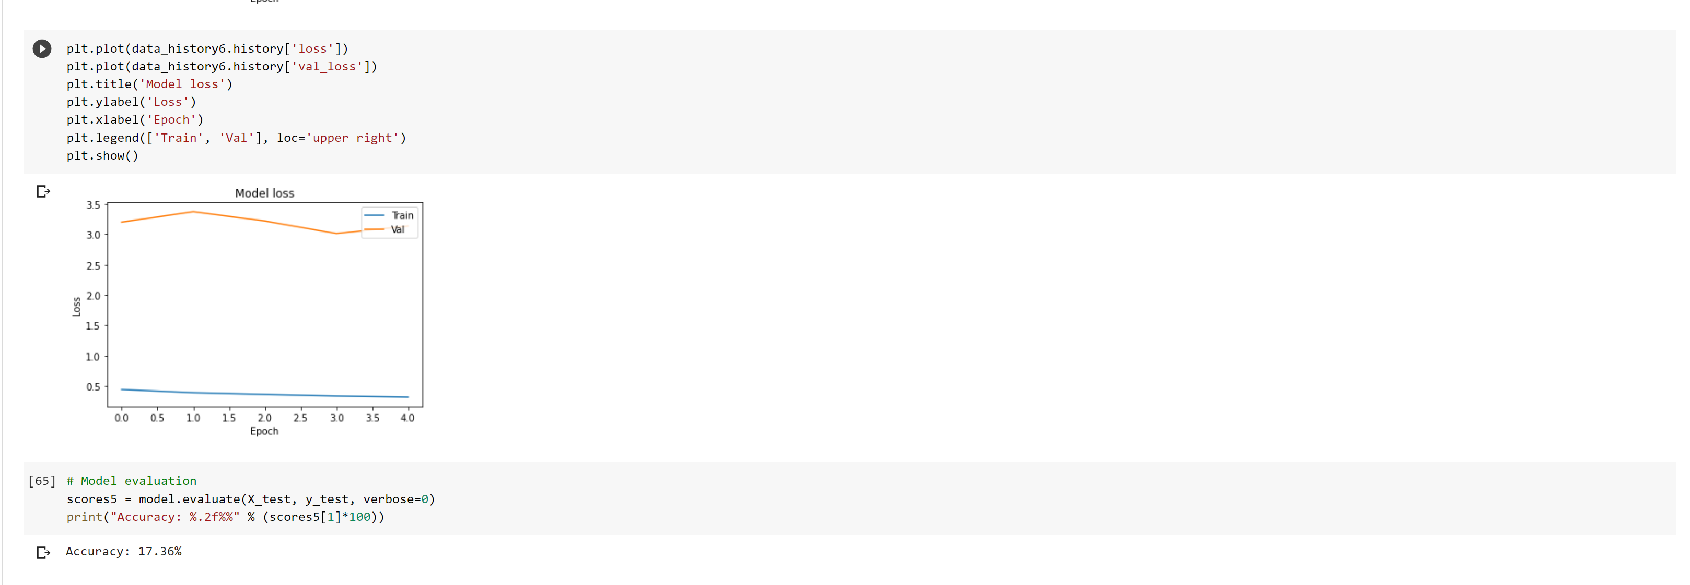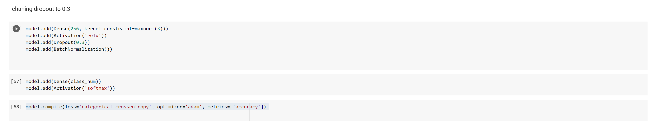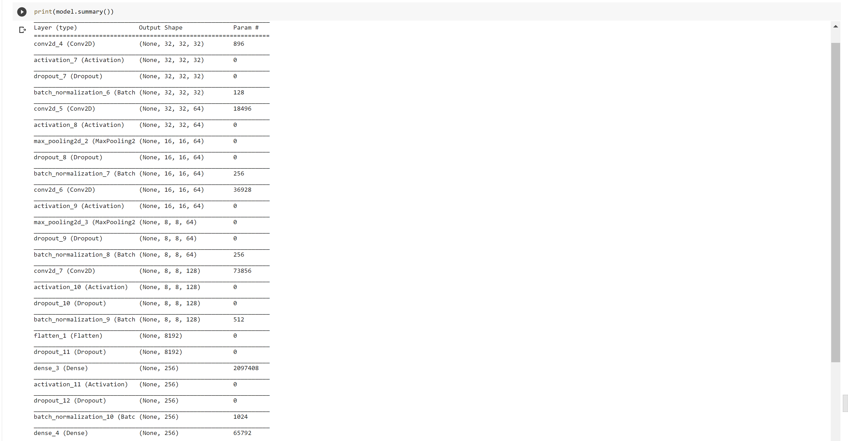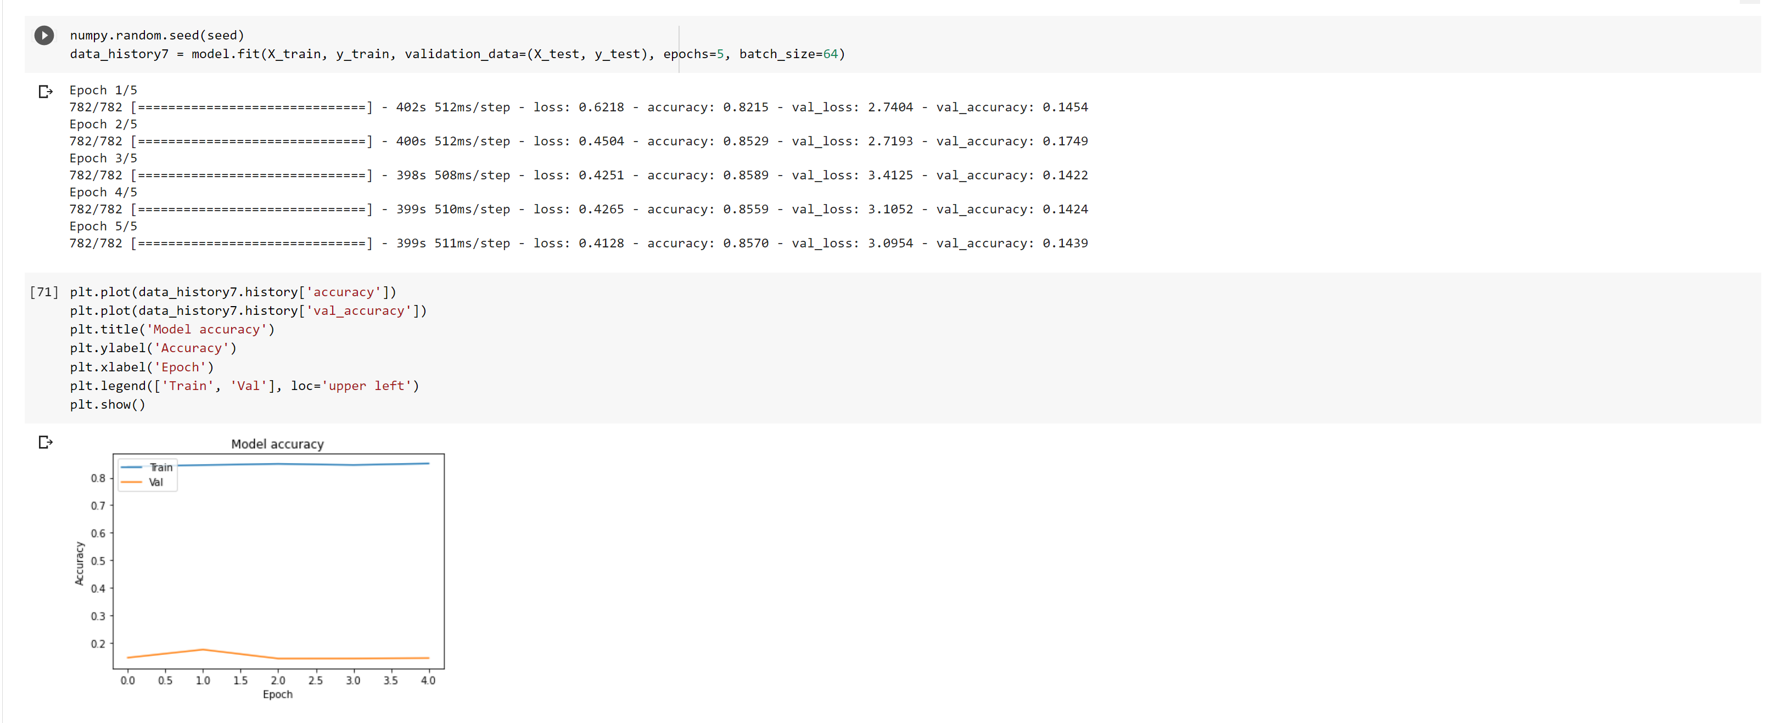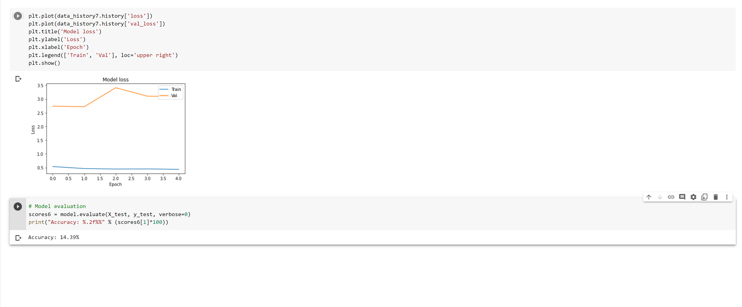

* 1. Output file link if applicable.

<https://github.com/UMKC-APL-BigDataAnalytics/icp5-irfancheemaa>

* 1. Video link (YouTube or any other publicly available video platform).

You should have access to the link. If there are any issues, please let me know.

<https://umkc.hosted.panopto.com/Panopto/Pages/Viewer.aspx?id=a7676aed-4d2a-4e69-95a5-ac440187923e>

* 1. Any inside about the data or the ICP in general

I enjoyed this topic and always wanted to learn more about it and how to implement it. It would be nice to learn few more variations of this method with smaller dataset.